Q#2: Write a report on Case Study of Netflix. Write detailed working with diagrams. The Rise of Streaming and its Impact on Traditional Television
Netflix has revolutionized the way we consume entertainment. It has shifted the traditional television
and entertainment industry towards a more personalized, on-demand model. Key Transformations
- Shift from Linear to On-Demand Viewing:

  - Traditional TV: Viewers were bound to specific broadcast schedules.

  - Netflix: Offers binge-watching, allowing viewers to watch shows at their own pace.

- Original Content Dominance:

  - Traditional TV: Relied heavily on syndicated content.

  - Netflix: Invests heavily in original series and movies, attracting a global audience.

- Data-Driven Personalization:

  - Traditional TV: Broadcasts to a mass audience.

  - Netflix: Utilizes algorithms to recommend content based on individual preferences.

- Global Reach and Localization:

  - Traditional TV: Primarily focused on domestic audiences.

  - Netflix: Offers localized content and subtitles, catering to a diverse global audience.

Key Factors Contributing to Netflix's Success and Differentiation

Netflix's dominance in the streaming market can be attributed to several key factors:

- Original Content Strategy:

  - High-Quality Productions: Netflix invests heavily in producing original series and movies, often with A-list talent.
  - Diverse Content Library: Catering to a wide range of tastes, from dramas and comedies to documentaries and anime.

  - Global Appeal: Creating content that resonates with audiences worldwide.

- Data-Driven Personalization:

  - Advanced Algorithms: Netflix uses sophisticated algorithms to analyze viewing habits and recommend tailored content.
  - Personalized Recommendations: Improving user experience and increasing engagement.

  - Dynamic Content Delivery: Optimizing the streaming experience based on individual preferences.

- Seamless User Experience:

  - Intuitive Interface: A user-friendly interface that is easy to navigate.

  - High-Quality Streaming: Consistent video quality and minimal buffering.

  - Multiple Device Compatibility: Accessing content across various devices.

- Strong Brand Reputation:

  - Innovative Approach: Pioneering the streaming industry and setting new standards.

  - Customer-Centric Focus: Prioritizing user satisfaction and addressing feedback.

  - Effective Marketing Campaigns: Promoting original content and building brand awareness.

Venn Diagram:

  - Netflix: Original content, data-driven personalization, seamless user experience, strong brand reputation

  - Other Streaming Platforms: Shared attributes like on- demand streaming, diverse content libraries, and global reach.
Netflix's Competitive Advantage

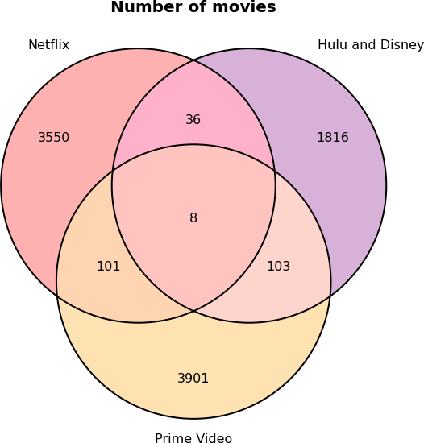
Netflix's Differentiation:

  - Unique Selling Proposition (USP): Original content, data- driven personalization, and strong brand reputation.

  - Competitive Advantage: By focusing on these key areas, Netflix has established a significant advantage over its competitors.
By combining these factors, Netflix has successfully differentiated itself from other streaming platforms and solidified its position as a leading entertainment provider.

Netflix's Data-Driven Personalization: A Deep Dive

Netflix's success hinges on its ability to deliver highly personalized content recommendations. The platform leverages sophisticated algorithms and data analytics to curate a unique viewing experience for each user.

How Netflix Personalizes Content:

- Data Collection:

  - Viewing History: Tracks what users watch, pause, and rewind.

  - Ratings and Reviews: Records user ratings and reviews for shows and movies.

  - Search and Browse Behavior: Analyzes user search queries and browsing habits.

  - Device Information: Collects data on the devices used to access Netflix.

- Algorithm Development:

  - Machine Learning Models: Develops complex algorithms to analyze user data and predict preferences.
  - Collaborative Filtering: Identifies similar users and recommends content they enjoyed.

  - Content-Based Filtering: Recommends content similar to what a user has watched in the past.
- Personalized Recommendations:

  - Home Page Customization: Tailors the home page to feature content likely to interest the user.
  - Row and Title Recommendations: Suggests specific rows and titles based on user preferences.
  - Personalized Rankings: Ranks content within rows to prioritize the most relevant options.

Flowchart:

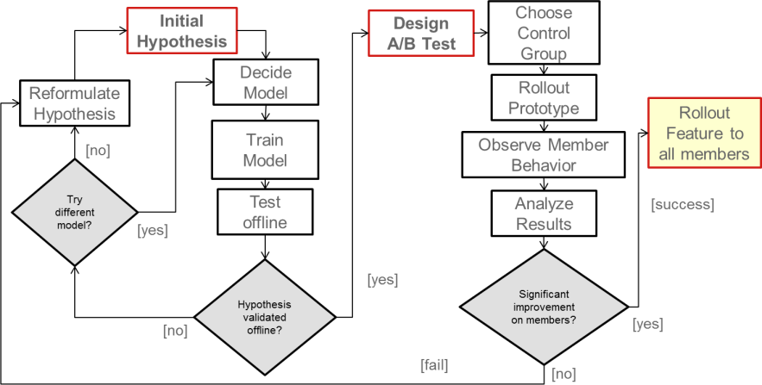
- Data Collection:

  - Viewing history

  - Ratings and reviews

  - Search and browse behavior

  - Device information

Data Processing:

  - Cleaning and preprocessing data
  - Feature engineering

Algorithm Development:

  - Machine learning models

  - Collaborative filtering

  - Content-based filtering

Personalized Recommendations:

  - Home page customization

  - Row and title recommendations

  - Personalized rankings

Impact on User Engagement:

  - Increased Viewing Time: Personalized recommendations keep users engaged for longer periods.

  - Reduced Churn: Satisfied users are less likely to cancel their subscriptions.

  - Enhanced User Experience: Tailored recommendations make it easier for users to discover new content they enjoy.
  - Higher Revenue: Increased engagement and reduced churn contribute to higher revenue for Netflix.

The Impact of Netflix Originals on Global Television and Film Production

Netflix's investment in original content has significantly reshaped the global television and film industry.

Key Impacts:

- Disruption of Traditional Production Models:

  - Increased Risk-Taking: Netflix's subscription model allows for bolder storytelling and experimentation with diverse genres and formats.

  - Global Production Hubs: The platform has led to the emergence of new production hubs beyond Hollywood, fostering local talent and industries.

Elevating the Role of the Creator:

  - Creative Freedom: Netflix often grants creators significant creative autonomy, resulting in innovative and groundbreaking shows.
  - Direct-to-Consumer Model: By bypassing traditional distribution channels, creators can reach a global audience directly.

Redefining the Television Viewing Experience:

  - Binge-Watching Culture: Netflix popularized the binge-watching phenomenon, transforming how audiences consume television.
  - Global Phenomenon: The platform has produced numerous international hits, transcending cultural boundaries.

Regional Content Restrictions and Licensing Challenges

Netflix operates in a global market, where content licensing and distribution rights vary significantly from country to country. This presents unique challenges in delivering a consistent and seamless viewing experience to its diverse user base.

Handling Regional Content Restrictions

To navigate these complexities, Netflix employs several strategies:

Geo-Blocking:

  - Netflix uses IP addresses to determine a user's location and restricts access to content that is not licensed for that region.
  - This ensures compliance with licensing agreements and prevents unauthorized viewing.

Content Curation:

  - Netflix curates its content library for each region, offering a mix of global titles and locally produced shows and movies.
  - This approach caters to the specific preferences of different audiences.

Content Licensing Negotiations:

  - Netflix negotiates complex licensing deals with content producers and distributors worldwide.
  - These agreements often involve exclusive rights, territorial restrictions, and windowing periods.

Challenges in Licensing and Distribution

Netflix faces several challenges in licensing and distribution:

High Licensing Costs:

  - Acquiring popular content can be expensive, especially for exclusive rights.

  - This impacts Netflix's profitability and ability to invest in original content.

Complex Licensing Agreements:

  - Navigating the intricate web of licensing rights and restrictions can be time-consuming and costly.
  - Different countries have varying copyright laws and regulations, further complicating the process.

Content Availability and Quality:

  - Ensuring consistent content availability and quality across different regions can be challenging.

  - Factors such as censorship, language barriers, and technical limitations can impact the user experience.

The Impact of Binge-Watching on Viewer Habits and Content Consumption

Netflix has significantly contributed to the rise of binge-watching, a phenomenon where viewers consume multiple episodes of a TV series in one sitting. This trend has reshaped the way audiences engage with content and has had far-reaching implications for the entertainment industry.

Key Impacts of Binge-Watching:

- Changed Viewer Expectations:

  - Immediate Gratification: Binge-watching caters to the desire for instant gratification, leading to higher viewer expectations for quick plot development and cliffhangers.
  - Immersive Viewing Experiences: Consuming multiple episodes consecutively creates a more immersive and intense viewing experience.

Influenced Content Creation:

  - Longer Seasons: Binge-watching has enabled creators to produce longer seasons with more complex storylines.

  - Cliffhanger Endings: To encourage binge-watching, shows often end seasons with cliffhangers, leaving viewers eager for the next season.

Altered Television Landscape:

  - Decline of Traditional TV: Binge-watching has contributed to the decline of traditional TV viewing, as audiences increasingly turn to streaming services.
  - Rise of Original Content: Streaming services like Netflix have invested heavily in original content to attract binge-watchers.

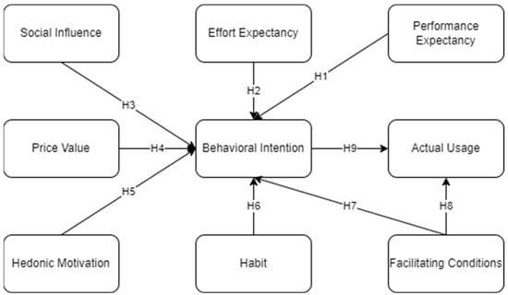

diagram showing the interconnections between bingewatching, viewer expectations, content creation, and the television landscape

  - Binge-Watching

    - Viewer Expectations: Immediate gratification, immersive experiences

    - Content Creation: Longer seasons, cliffhanger endings

    - Television Landscape: Decline of traditional TV, rise of original content

Netflix has played a pivotal role in popularizing binge-watching by:

  - Releasing Entire Seasons at Once: This strategy encourages viewers to watch multiple episodes consecutively.
  - Creating Compelling Storytelling: Netflix's original series often feature complex storylines and intricate character arcs, making them ideal for binge-watching.

  - Personalized Recommendations: Netflix's algorithm suggests shows and movies based on viewing history, further fueling binge-watching.

The Role of Technology in Delivering High-Quality Streaming Experiences on Netflix

Netflix relies heavily on technology to provide seamless and high-quality streaming experiences to its millions of subscribers. The platform has continuously adapted to advancements in internet infrastructure and device capabilities to ensure optimal performance.

Key Technological Factors:

- Content Delivery Networks (CDNs):

  - Netflix utilizes a vast network of servers distributed globally to deliver content efficiently.
  - CDNs reduce latency and improve streaming quality by caching content closer to users.

Video Encoding and Compression:

  - Advanced video codecs are employed to compress video files without compromising quality.
  - This enables efficient streaming and reduces bandwidth requirements.

Adaptive Bitrate Streaming (ABR):

  - Netflix adjusts the video bitrate dynamically based on network conditions and device capabilities.

  - This ensures smooth playback, even in low-bandwidth environments.

Edge Computing:

  - By processing data closer to the source, edge computing reduces latency and improves response times.
  - This is especially beneficial for interactive features and personalized recommendations.

Artificial Intelligence and Machine Learning:

  - AI and ML algorithms are used for tasks such as:

    - Content Recommendation: Suggesting tailored content to individual users.

    - Quality Control: Monitoring and improving video quality.

    - Fraud Detection: Identifying and preventing account fraud

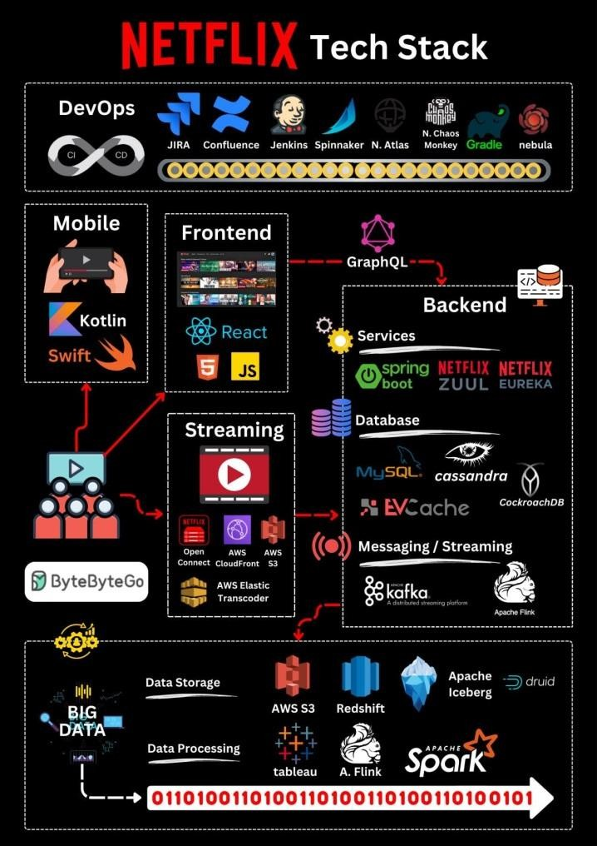
layered diagram showcasing Netflix's

Layers:

  - Top Layer: User Interface

  - Middle Layer: Application Servers

  - Bottom Layer: Content Delivery Network (CDN)

Arrows indicating data flow:

  - User requests content from the UI.

  - Application servers process the request and interact with the CDN.

  - The CDN delivers the content to the user's device.

Netflix's Approach to Data Privacy and Security

Netflix has prioritized data privacy and security as it collects and analyzes vast amounts of user data to personalize content recommendations. The company has implemented several measures to safeguard user information:

Transparent Data Practices:

  - Clear Privacy Policy: Netflix maintains a transparent privacy policy that outlines how user data is collected, used, and shared.
  - Informed Consent: Users are informed about data collection and have the option to opt out or adjust their privacy settings.

Robust Security Measures:

  - Encryption: Netflix employs strong encryption techniques to protect user data both at rest and in transit.

  - Regular Security Audits: The company conducts regular security audits and vulnerability assessments to identify and address potential threats.
  - Incident Response Plans: Netflix has well-defined incident response plans to quickly mitigate the impact of security breaches.

Data Minimization:

  - Limited Data Collection: Netflix collects only the necessary data to provide its services and improve user experience.

  - Data Retention Policies: The company has specific data retention policies to limit the storage of sensitive information.

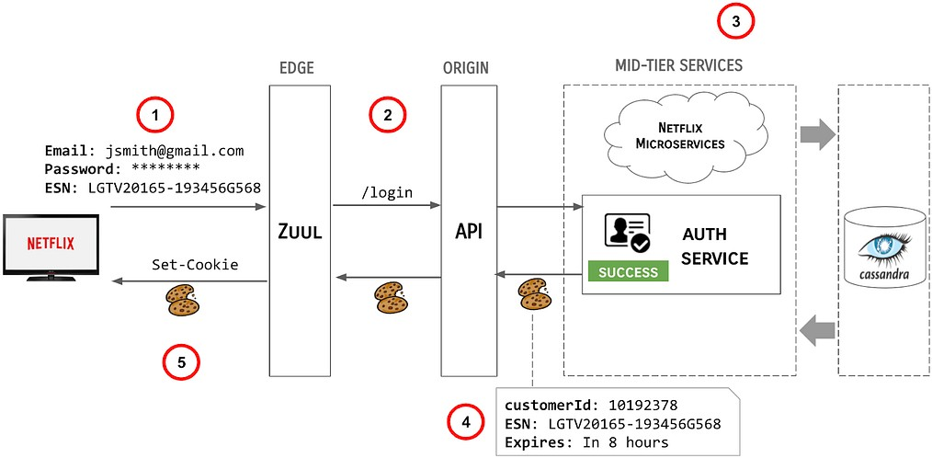

Layered Diagram:

Layer 1: User Data

  - Personal information

  - Viewing history

  - Preferences

Layer 2: Data Collection and Processing

  - Secure data collection methods

  - Data anonymization and aggregation

  - Regular data audits

Layer 3: Security Measures

  - Encryption

  - Firewalls

  - Intrusion detection systems

  - Regular security assessments

Layer 4: Privacy Policies and Compliance
  - Transparent privacy policy

  - Compliance with data protection regulations (e.g., GDPR, CCPA)

  - User consent and control over data

Layer 5: Incident Response

  - Incident detection and response plans

  - Regular security training for employees

  - Third-party security audits

Netflix's Innovation Amidst Increasing Competition

The streaming industry has become increasingly competitive, with numerous players vying for market share. This intensified competition presents both challenges and opportunities for Netflix.

Potential Effects of Increased Competition:

  - Market Share Erosion: As new players enter the market, they may attract subscribers away from Netflix.
  - Rising Content Costs: The need to produce high-quality original content to stay competitive can drive up costs.

  - Increased Price Pressure: Competition can lead to price wars, impacting Netflix's revenue. Netflix's Innovation Strategies:
To maintain its competitive edge, Netflix has implemented several innovative strategies:

- Content Differentiation:

  - Niche Content: Investing in niche genres and international content to cater to diverse audiences.
  - Original Content: Continuously producing high-quality original series and films.

  - Exclusive Licensing Deals: Securing exclusive rights to popular content.

- Personalized User Experience:

  - Advanced Algorithms: Utilizing sophisticated algorithms to tailor recommendations to individual preferences.

  - Interactive Content: Experimenting with interactive storytelling formats.

- Expanding Distribution Channels:

  - Mobile-First Strategy: Optimizing content for mobile devices.

  - Gaming Integration: Incorporating gaming into the Netflix platform.

  - Global Expansion: Expanding into new markets and localizing content.

Overcoming the Hurdles: Content Discovery and Retention at Netflix

Netflix has mastered the art of keeping viewers engaged by tackling the challenges of content discovery and retention. Here's a breakdown of their strategies and how they use data to win over users in the long run.

Content Discovery: Finding the Perfect Match

  - Personalized Recommendations: The heart of Netflix's content discovery lies in its sophisticated recommendation engine. This algorithm analyzes user data like viewing history, ratings, and browsing behavior to suggest titles that align with individual preferences.

  - Content Diversity and Curation: Netflix offers a vast library of content across genres and formats. Curated rows like "Trending Now" and "Because You Watched" cater to current interests, while genre-specific sections help users explore new niches.
  - Search Functionality: Users can search by title, actor, director, or even keywords like "funny" or "suspenseful" to refine their discoveries.
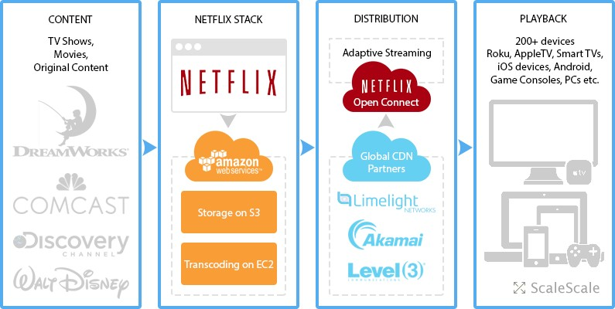
- User Interaction: User watches a show, rates content, or browses categories.

- Data Collection: Viewing data, ratings, search history, and device usage are collected.

- Recommendation Engine: Algorithm analyzes user data and identifies patterns.

- Content Suggestions: Personalized recommendations appear on the user's homepage and within categories.

- Content Curation: Curated rows and genre sections further enhance discoverability.

- User Engagement: User watches recommended content, further feeding data into the system.

Retention Strategies: Keeping Viewers Hooked

  - Original Content: Netflix invests heavily in producing high-quality original series and movies. This exclusive content creates a sense of urgency and keeps users coming back for more.
  - Regular Content Updates: New seasons, movies, and documentaries are added frequently, providing a constant stream of fresh content and preventing user churn.

  - Interactive Experiences: Netflix has experimented with interactive content formats like "Black Mirror: Bandersnatch" to increase user engagement and create a more immersive viewing experience.
  - Downloadable Content: The ability to download content for offline viewing makes Netflix more convenient and caters to users with limited internet access.

Conclusion

Netflix has revolutionized the entertainment industry by shifting from traditional linear television to on- demand streaming. The platform's focus on original content, data-driven personalization, and global reach has attracted millions of subscribers worldwide. However, challenges like data privacy, content discovery, and retention continue to shape the industry. By addressing these challenges through robust security measures, innovative recommendation algorithms, and diverse content offerings, Netflix aims to maintain its position as a dominant force in the streaming landscape.

